CYCLOPS PAN TILT CONTROLLER v.1106 Assembly Notes:

==============================
GERBER
-----
Filenames are “CYCLOPS PANTILT9-2” with the following extensions:

.DRL DRILL FILE

.OTL BOARD OUTLINE
.TOP TOP METAL
.BOT BOTTOM METAL

.SMB SOLDER MASK BOTTOM
.SMT SOLDER MASK TOP
.SPB SOLDER PASTE BOTTOM
.SPT SOLDER PASTE TOP
.SST SILK SCREEN TOP
.SSB SILK SCREEN BOTTOM

IMPORTANT NOTE(S):
-----
All through-hole parts are to be inserted from the BOTTOM side.

J3 and J4 are identical footprints. Exercise caution to ensure that each component is installed on the correct side of the board. J4 (DF9-51P) is on the TOP by silk marking “CYCLOPS I/F”, J3 (DF9-51S) is on the BOTTOM by silk marking “MOTE I/F”. THESE ARE DIFFERENT MFR PART NUMBERS and this SUBTLE difference was overlooked on our last build (rev. 0706).

DO NOT POPULATE THESE PARTS:
-----
Item # Part Reference
(see BOM v.1106)
There is a 5 pin header in the lower-left corner of the board that does not have a reference designator and is not populated.

TOP LAYER:

DIODE
-----
Align the diodes with the bar on the package to the bar on the silk screen.
Item # Part Reference
11 D2

LED
Item # Part Reference
12 D3 : Align the LED with the green line on the package to the pointy shape (“tent”) on the silk screen.

POLAR CAPACITORS
-----
Item # Part Reference
4 C12, C13, C16
5 C18
iii: Align the bar on the package with the tent shape on the silk screen outline.

STEP-UP CONVERTER
-----
Item # Part Reference
35 U4 : Align the dot on the package with the rectangular pad on the silk screen, near C3.

REGULATOR
-----
Item # Part Reference
34 U3 : Pin1 is rectangular; crossbar on silk at pin1 end of silk part outline; Pin1 is a dot-marked on actual part.

BOARD-TO-BOARD CONNECTOR
-----
Item # Part Reference
17 J4 : Align the connector with the holes. The side with more pads faces the edge of the board.

BOTTOM LAYER:

MOSFET
Item # Part Reference
13 HXFT1 : Pin 1 is indicated on the package with a dot, align that to the rectangular pad on the silk screen, near the C21. Pin 1 is also indicated with a cross bar and a dot on the silk-screen.

DIODE
-----
Align the diodes with the bar on the package to the bar on the silk screen.
Item # Part Reference
10 D1

SWITCH
-----
Item # Part Reference
32 U1 : Place the switch so that it faces the outside of the board.

BOARD-TO-BOARD CONNECTOR
-----
Item # Part Reference
16 J3 : Align the connector with the holes. The side with more pads faces the edge of the board.

MAGNETIC SENSOR
------------------------------
Item # Part Reference
21 MAG2
: Pin1 is indicated on the actual part with a dot as shown; There is no direct Pin1 marking on the PCB silkscreen. This is an omission on our part. Pad1 is the corner closest to C24 (which is the same corner that is closest to the .09” finished plated mechanical hole). Please align accordingly.
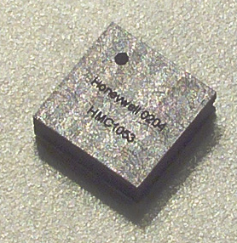

ACCELEROMETER SENSOR
------------------------------
Item # Part Reference
1 ACCEL1
: Pin1 is indicated on the actual part with a dot as shown; Pin1 is indicated on the PCB silk with a “1” and a rectangular pad. Please align accordingly.
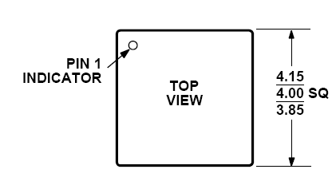

SERVO CONNECTORS
------------------------------
Item # Part Reference
14 J1 J2
: Install from BOTTOM. Pins face away from PCB interior. Solder flush and level to PCB to ensure clean 90 degree bend (i.e. pins parallel to pcb surface). Thanks!

***************************************************************************
CALL US IF YOU HAVE QUESTIONS, ANY TIME DAY OR NIGHT (INCLUDING WEEKENDS, HOLIDAYS, ETC):

UCLA NES Laboratory (310-825-7707, 310-206-5698)
Jonathan Friedman, jf@ee.ucla.edu, 404-259-8168
***************************************************************************

